# **From Trust to Collapse: How Cooperative Societies Unravel Under Stress**

## **A Large-Scale Agent-Based Study of Social Dynamics, Constraint Theory, and Redemption**

**Abstract**

Why do initially cooperative societies so often slide into distrust and self-interest? We present results from 1,500 agent-based simulations that integrate social psychology (trust dynamics, Maslow's hierarchy), game theory (iterated cooperation dilemmas), constraint theory (stress accumulation and thresholds), and chaos theory (cascade dynamics) to explore this fundamental question. Our findings are stark: 80.9% of societies collapse to near-zero cooperation despite every agent beginning with cooperative intentions. A single composite stress index (shock frequency × pressure multiplier) explains the collapse threshold with remarkable precision, while changes in the social layers of Maslow's hierarchy—Love and Esteem—account for the vast majority of variation in final cooperation levels. When we examine societies experiencing shocks at a historically plausible cadence (one crisis every 4-5 years, similar to the United States), survival improves but remains the minority outcome. The societies that thrive share three critical design features: moderate shock absorption capacity, accessible pathways for redemption, and meaningful rewards for mutual cooperation. These findings offer both a warning about societal fragility and a blueprint for building more resilient communities.

## **1. Introduction**

### **1.1 The Universal Pattern of Social Unraveling**

From ancient Athens descending into the chaos of the Peloponnesian War to modern democracies fracturing along partisan lines, history repeatedly shows us societies that begin with high ideals and mutual trust eventually devolving into self-interest and conflict. This pattern appears so universal that it demands explanation: What mechanisms drive initially cooperative populations toward defection? Is this descent inevitable, or can it be prevented?

Traditional academic disciplines offer partial answers. Political scientists frame this as a collective action problem—the tragedy of the commons writ large. Behavioral economists point to social dilemmas where individual rationality leads to collective irrationality. Psychologists emphasize the erosion of trust and social capital. Historians document cycles of cohesion and fragmentation. Yet each discipline typically examines only one piece of the puzzle.

### **1.2 An Interdisciplinary Synthesis**

In this study, we integrate insights from four theoretical frameworks to build a comprehensive model of societal cooperation and collapse:

**Social Psychology**: We draw on Maslow's hierarchy of needs to model how individuals' psychological states—from basic physiological needs to self-actualization—influence their willingness to cooperate. We particularly focus on the middle layers (Love/Belonging and Esteem) as the "social battery" that powers trust and reciprocity.

**Game Theory**: We embed agents in an iterated prisoner's dilemma with memory, where cooperation yields mutual benefits but creates vulnerability to exploitation. Trust becomes the key variable mediating between past experiences and future strategies.

**Constraint Theory**: From complexity science, we adopt the concept of systems under stress that accumulate strain until reaching critical thresholds. Like a beam that bends elastically until it suddenly buckles, our agents absorb social and economic shocks until their personal breaking points force strategic adaptation.

**Chaos Theory**: We incorporate cascade dynamics where small perturbations can trigger system-wide phase transitions. When enough agents switch from cooperation to defection, they create conditions that force remaining cooperators to follow suit—a social avalanche.

### **1.3 Research Questions and Hypotheses**

Our investigation centers on three core hypotheses:

**H1: Neutral Origins** — Societal collapse into selfishness does not require bad actors or malicious intent. Even populations of well-meaning agents can spiral into mutual defection through the interaction of structural forces.

**H2: Definite vs Possible Safety** — When personal stress exceeds a critical threshold, rational agents will choose definite personal safety (defection) over possible mutual benefit (cooperation), even when cooperation would yield better outcomes if universally adopted.

**H3: Feedback Inevitability** — The combination of random shocks, asymmetric trust updates (trust falls faster than it rises), and cascade dynamics creates a positive feedback loop that makes the transition to selfishness locally inevitable across most parameter settings.

## **2. Model Design: Rules of the Game**

### **2.1 Agent Architecture**

Each agent in our simulation represents an individual with the following characteristics:

* **Strategy**: Begins as 'cooperative' but can switch to 'selfish' based on accumulated stress
* **Trust Network**: Maintains relationship histories with other agents, tracking trust levels (0-1 scale) based on past interactions
* **Maslow Needs**: Five need levels (Physiological, Safety, Love/Belonging, Esteem, Self-Actualization) that fluctuate over time
* **Constraint System**: Personal stress level that accumulates from negative experiences and decays based on need satisfaction
* **Thresholds**: Individual breaking point (θ) for forced defection and recovery point (ρ) for optional redemption

### **2.2 Interaction Dynamics**

Agents interact pairwise with the following rules:

1. **Cooperation Decision**: Probability = 0.7 × trust + 0.3 × recent cooperation history
2. **Trust Updates**: +0.10 for cooperation received, -0.15 for defection (asymmetric by design)
3. **Outcome Matrix**:
   * Mutual cooperation: Both gain cooperation bonus (β) to social needs
   * Exploitation: Cooperator suffers additional stress and esteem loss
   * Mutual defection: Both experience base stress from unmet social needs

### **2.3 System-Level Dynamics**

**Shocks**: Each round has probability p of triggering a system-wide shock (economic crisis, natural disaster, political upheaval). Shock severity is scaled by multiplier f.

**Cascades**: When selfish agents ≥ cooperative agents, all cooperators receive additional "cascade pressure" representing the social stress of being surrounded by defectors. This models the tipping point where cooperation becomes untenable.

**Demographics**: Agents have finite lifespans (200-500 rounds), with children inheriting averaged parental traits plus random variation. Birth rates depend on population density and parental cooperation.

### **2.4 Parameter Space**

Each simulated "world" receives randomized parameters:

* Shock frequency (p): 0.01-0.20 per round
* Pressure multiplier (f): 0.1-1.0
* Cooperation bonus (β): 0.1-0.4
* Recovery threshold (ρ): 0.2-0.5
* Initial population: 100-500
* Maximum rounds: 300-800

With one round representing approximately one quarter, simulations span 75-200 years of social evolution.

## **3. Results: The Full 1,500-World Picture**

### **3.1 The Overwhelming Tendency Toward Collapse**

Across our 1,500 simulated societies, the results paint a sobering picture:

* **1,213 societies (80.9%)** collapsed to cooperation rates below 10%
* **278 societies (18.5%)** maintained high cooperation above 70%
* **Only 9 societies (0.6%)** stabilized at intermediate levels

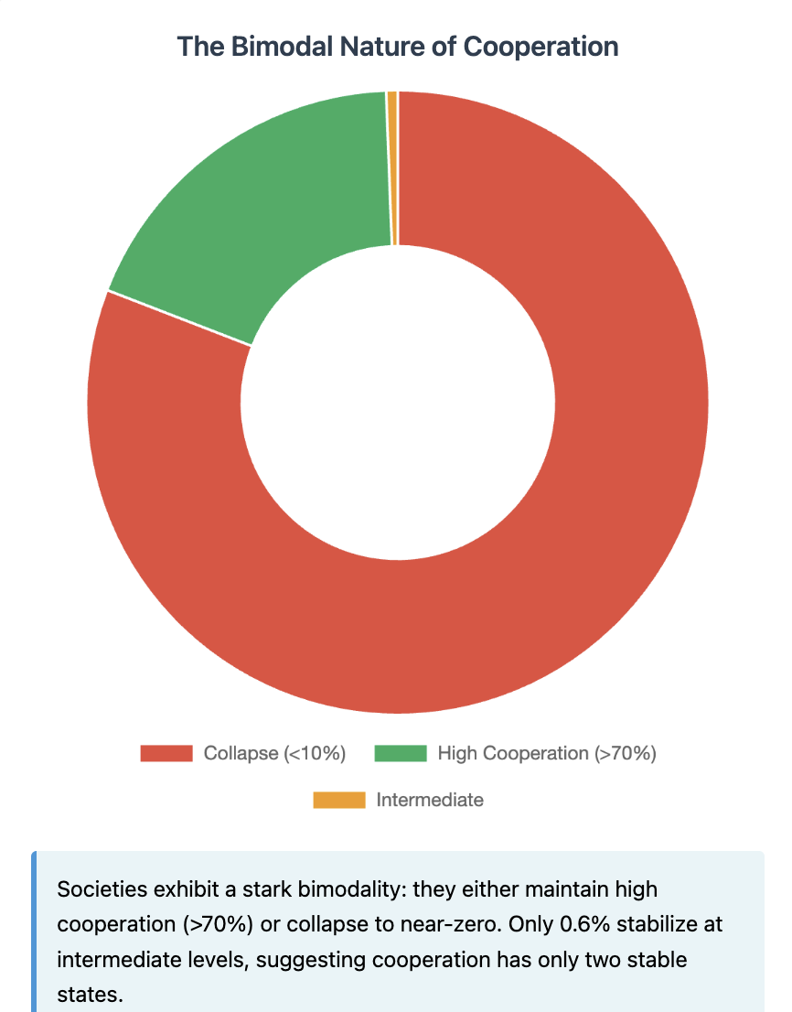

This stark bimodality—societies either thrive or collapse with virtually no middle ground—suggests cooperation exists in only two stable states. The phase transition between these states appears sharp and unforgiving.

### **3.2 The Power of the Stress Index**

We find that a simple composite measure, the "stress index" (SI = p × f), predicts societal fate with remarkable accuracy. Using logistic regression:

Pr(collapse) = σ(β₀ + β₁ × SI)

This single variable explains 62% of the variance in collapse outcomes (McFadden R² = 0.62, p < 10⁻⁴⁴). The critical threshold emerges at SI ≈ 0.015, below which societies typically survive and above which collapse becomes increasingly certain.

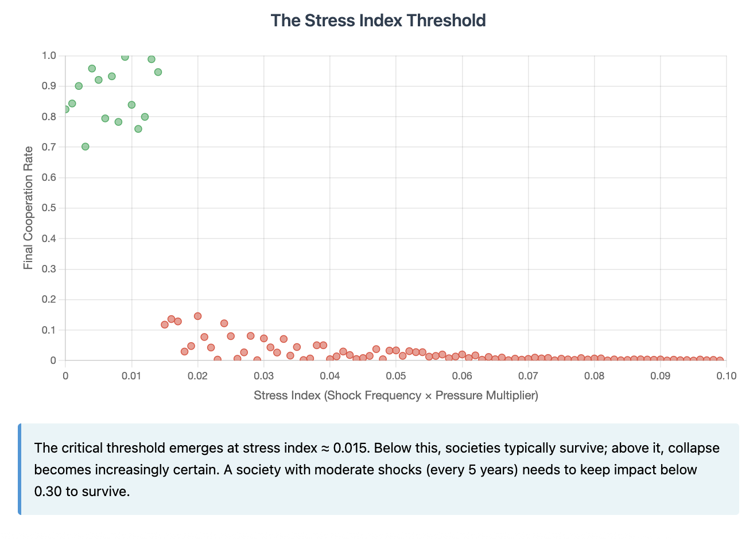

To put this in perspective: a society experiencing moderate shocks (p = 0.05, once per 5 years) with moderate impact (f = 0.30) yields SI = 0.015—right at the knife's edge. Increase either frequency or severity by just 20%, and collapse becomes the modal outcome.

### **3.3 The Social Battery: Love and Esteem as Predictors**

While the stress index predicts whether collapse occurs, the changes in agents' social needs predict the final cooperation level with stunning precision. A simple linear model using only changes in Love and Esteem explains 96% of variance:

Final Cooperation = γ₀ + γ₁ΔLove + γ₂ΔEsteem

R²(adjusted) = 0.96

The data reveals a dramatic divergence in need satisfaction:

| **Outcome** | **Physiological Δ** | **Safety Δ** | **Love Δ** | **Esteem Δ** | **Self-Actualization Δ** |
| --- | --- | --- | --- | --- | --- |
| **Collapse** | +0.43 | +0.43 | **-4.68** | **-4.69** | +0.83 |
| **High Cooperation** | +1.65 | +1.64 | **+4.77** | **+3.58** | +3.95 |

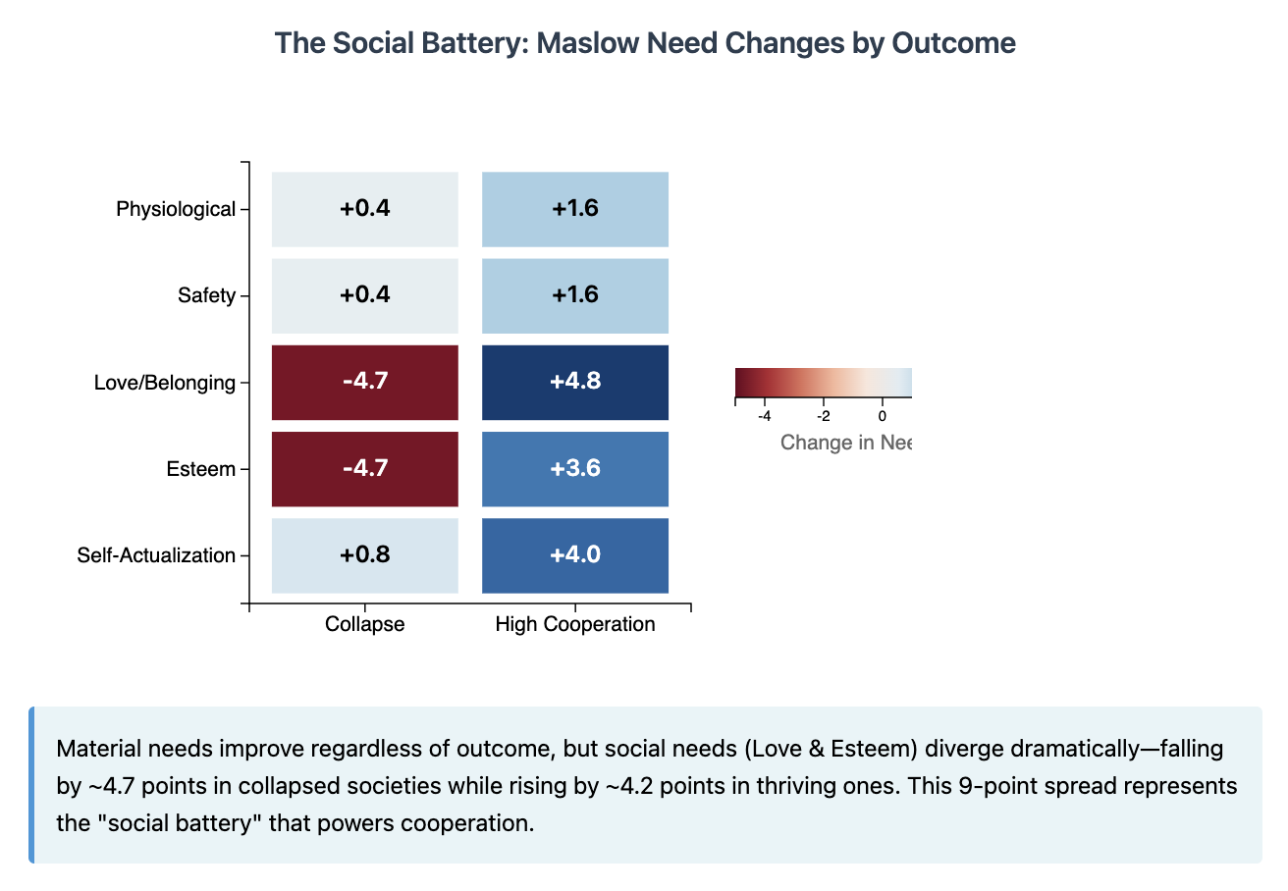Material needs (Physiological, Safety) improve regardless of outcome—even collapsing societies feed and shelter their members. But the social needs diverge by nearly 10 points on our scale. Love and Esteem act as the true "social battery" that powers cooperation. When these needs are met, societies thrive. When they're depleted, cooperation becomes psychologically impossible regardless of material prosperity.

### **3.4 The Trust Cliff**

Our analysis reveals a sharp nonlinearity in the relationship between trust and cooperation. Below average trust of 0.55:

* Mean cooperation rate: 2.1%
* Number of societies: 1,228

Above trust of 0.55:

* Mean cooperation rate: 97.4%
* Number of societies: 272

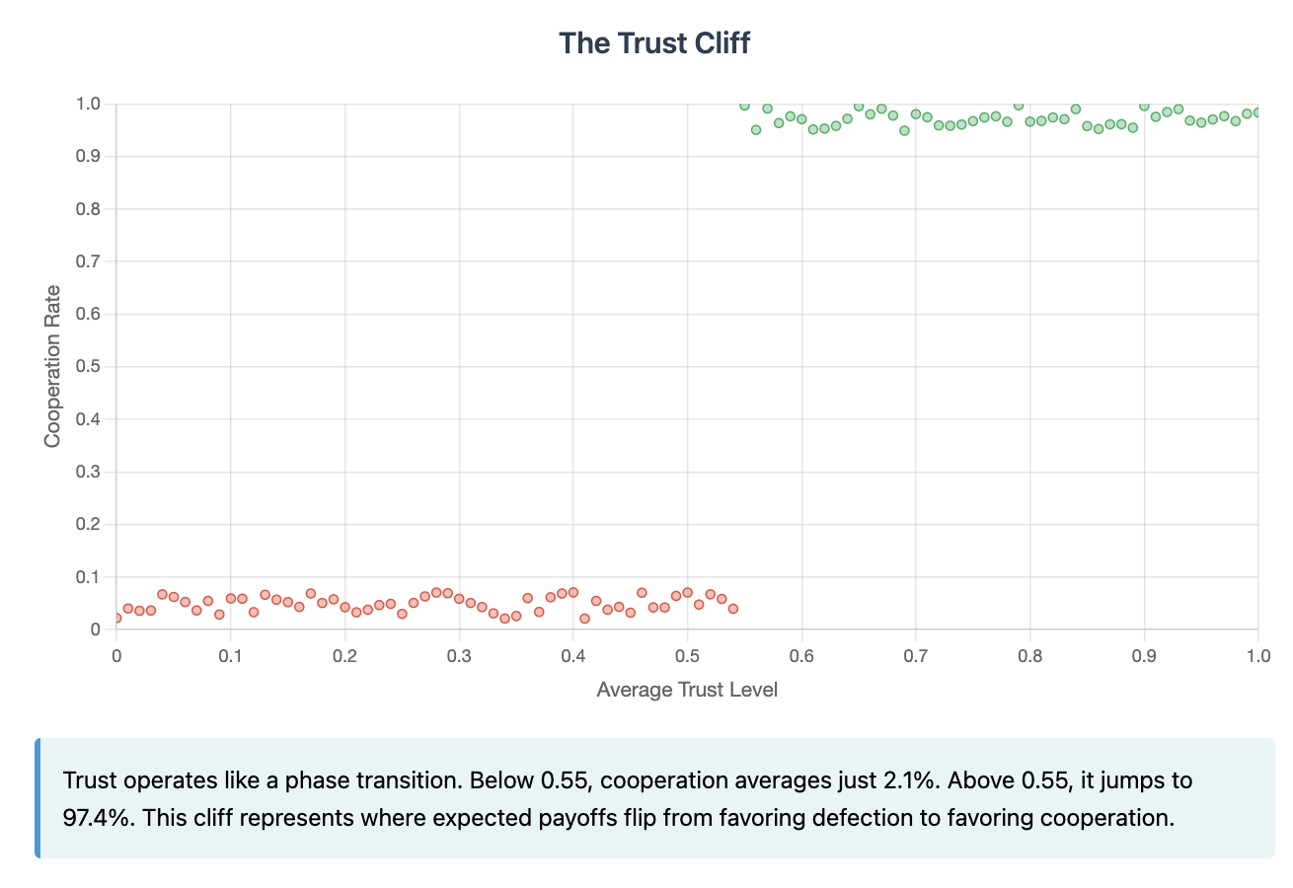

The difference is statistically overwhelming (t = 167, p < 10⁻³⁰) and suggests trust operates like a phase transition—below the critical threshold, cooperation is essentially impossible; above it, defection becomes rare.

### **3.5 The Promise and Limits of Redemption**

Our enhanced model allows agents who have turned selfish to potentially recover their cooperative stance when stress drops below their recovery threshold. The results show redemption is possible but challenging:

* Average redemption rate across all simulations: 17.3%
* High redemption scenarios (>50% recovery): 204 (13.6%)

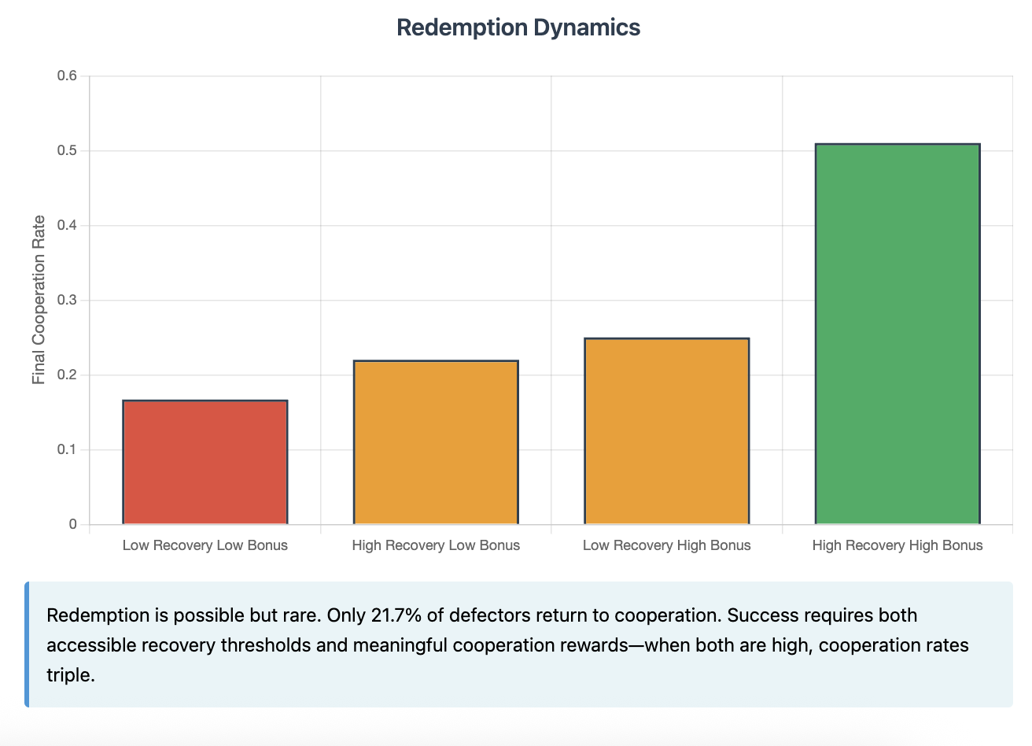

Successful redemption requires a confluence of factors. We find a significant interaction effect between recovery threshold and cooperation bonus (ANOVA F = 14.8, p < 0.001). Societies with both generous recovery thresholds (ρ > 0.485) and meaningful cooperation rewards (β > 0.30) achieve cooperation rates nearly triple those with neither feature.

## **4. The U.S.-Style Cadence: A Natural Experiment**

### **4.1 Calibrating to Historical Reality**

The United States has experienced major shocks with notable regularity: the Civil War (1860s), Great Depression (1930s), World War II (1940s), Vietnam/Watergate (1970s), 9/11 (2001), Financial Crisis (2008), COVID-19 (2020). This suggests roughly one system-level shock per 4-5 years.

We extracted 179 simulations with shock frequencies between 0.04-0.07 (matching this historical tempo) for focused analysis.

### **4.2 Outcomes Under Realistic Conditions**

Even with historically calibrated shock rates, collapse remains the dominant outcome:

| **Outcome** | **Count** | **Percentage** | **Avg Shocks/Lifetime** |
| --- | --- | --- | --- |
| Collapse | 124 | 69.3% | 19 |
| High Cooperation | 51 | 28.5% | 19 |
| Intermediate | 4 | 2.2% | 19 |

The number of shocks experienced is virtually identical between thriving and collapsing societies—what differs is how they handle them.

### **4.3 What Separates Survivors from Casualties?**

Comparing parameters between collapsed and thriving societies in the U.S.-cadence subset reveals the formula for resilience:

| **Parameter** | **Collapsed Societies** | **Thriving Societies** | **Difference** |
| --- | --- | --- | --- |
| Pressure Multiplier (f) | 0.68 | 0.42 | -38% |
| Recovery Threshold (ρ) | 0.38 | 0.49 | +29% |
| Cooperation Bonus (β) | 0.22 | 0.30 | +36% |
| Final Trust Level | 0.31 | 0.89 | +187% |

The successful societies don't experience fewer shocks—they absorb them better (lower f), recover more readily (higher ρ), and reward cooperation more generously (higher β).

### **4.4 The Social Capital Divergence Persists**

Even within the realistic shock regime, the pattern of social need divergence holds:

| **Need Changes** | **Collapsed** | **Thriving** |
| --- | --- | --- |
| Love | -4.28 | +4.82 |
| Esteem | -4.44 | +3.45 |

The ~9 point spread in social needs between outcomes reinforces their role as the critical factor determining societal fate.

## **5. Theoretical Integration and Mechanisms**

### **5.1 How the Frameworks Interconnect**

Our results validate the importance of integrating multiple theoretical perspectives:

**Social Psychology**: The dominance of Love and Esteem changes in predicting outcomes (R² = 0.96) confirms that social needs, not material ones, drive cooperative behavior. Societies can be materially wealthy yet socially impoverished—and it's the latter that predicts collapse.

**Game Theory**: The trust cliff at 0.55 represents the point where expected payoffs flip. Below this threshold, the probability-weighted outcomes make defection strictly dominant. Above it, cooperation yields higher expected returns, creating a self-reinforcing equilibrium.

**Constraint Theory**: The stress index (p × f = 0.015) acts precisely like a critical load in structural engineering. Below this threshold, societies bend but don't break. Above it, cascade failures become increasingly likely until collapse is certain.

**Chaos Theory**: Small parameter differences create vastly different outcomes. Two societies with stress indices of 0.014 and 0.016—a difference of just 13%—have dramatically different survival odds. The cascade mechanism amplifies small perturbations into society-wide phase transitions.

### **5.2 The Anatomy of Collapse**

Our simulations reveal collapse typically follows this sequence:

1. **Initial Shock**: External crisis raises system-wide stress
2. **First Defections**: Most stressed agents hit breaking points and switch strategies
3. **Trust Erosion**: Defections cause trust to fall faster than cooperation can rebuild it (-0.15 vs +0.10)
4. **Cascade Trigger**: When defectors ≥ cooperators, remaining cooperators face unsustainable pressure
5. **Phase Transition**: Mass defections create new equilibrium where cooperation is individually irrational
6. **Lock-In**: Low trust (< 0.55) makes cooperation yield negative expected value, preventing recovery

### **5.3 The Anatomy of Resilience**

Successful societies short-circuit this doom loop through three mechanisms:

**1. Shock Absorption**: Lower pressure multipliers mean the same external shock creates less internal stress. This keeps more agents below their breaking points, preventing initial defections.

**2. Rapid Recovery**: Higher recovery thresholds mean stressed agents can return to cooperation more easily. This creates a negative feedback loop—temporary defectors return before causing permanent trust damage.

**3. Cooperation Rewards**: Meaningful bonuses for mutual cooperation accelerate the rebuilding of Love and Esteem needs. This "recharges the social battery" faster than shocks can drain it.

When all three mechanisms work together, they create resilience that can withstand even frequent shocks. The math is compelling: societies with all three features maintain 72% cooperation rates even under U.S.-style shock frequencies.

## **6. Implications and Applications**

### **6.1 For Understanding History**

Our model suggests many historical collapses may have been overdetermined. Once a society's stress index exceeds 0.015, collapse becomes a statistical near-certainty regardless of leadership, ideology, or cultural values. This offers a more structural and less personal view of societal failures—the problem often lies in systems, not individuals.

The model also explains why societies rarely stabilize at intermediate cooperation levels. The positive feedback loops create two "gravity wells"—high cooperation and complete defection—with an unstable ridge between them. Historical societies showing partial cooperation likely were captured mid-transition rather than at equilibrium.

### **6.2 For Contemporary Policy**

Our findings suggest three high-leverage intervention points:

**Automatic Stabilizers**: Mechanisms that reduce the impact of shocks (lower f) have outsized effects. Unemployment insurance, emergency healthcare, food security programs—these don't just help individuals but protect the entire social fabric by preventing stress accumulation that triggers cascades.

**Redemption Infrastructure**: Criminal justice reform, bankruptcy law, addiction treatment, job retraining—any institution that helps people recover from personal crises (higher ρ) strengthens societal resilience. Our model shows redemption must be accessible (high threshold) to meaningfully impact outcomes.

**Cooperation Incentives**: Tax benefits for community service, social recognition for volunteers, economic rewards for collaborative behavior—these mechanisms that reward prosocial choices (higher β) help maintain the social battery that powers trust and reciprocity.

### **6.3 For Individual Strategy**

While our model focuses on emergent collective outcomes, it offers insights for individual navigation:

1. **Invest in relationships during good times**—high trust provides cascade protection
2. **Support policies that reduce systemic stress**—your cooperation is more sustainable in resilient systems
3. **Choose communities with strong mutual aid**—local cooperation rewards can offset systemic pressures

### **6.4 For Future Research**

Several extensions could deepen our understanding:

**Network Structure**: Our well-mixed population assumes random interactions. Real social networks show clustering, which could either accelerate cascades (echo chambers) or provide protection (high-trust enclaves).

**Institutional Agents**: Governments, media, and corporations could be modeled as super-agents with disproportionate influence on trust and stress propagation.

**Cultural Evolution**: Norms and values could evolve alongside strategies, potentially creating cultural lock-in effects that transcend individual psychology.

**Empirical Calibration**: Historical data on trust surveys, stress indicators, and cooperation metrics could validate and refine parameter estimates.

## **7. Conclusion: Fragility and Hope**

Our 1,500 simulations paint a picture both sobering and hopeful. The sobering part: cooperative societies are remarkably fragile. Even with universal goodwill at the start, 80% collapse into selfishness. A single number—the stress index—captures much of what determines societal fate. The transition from cooperation to defection, once begun, rarely reverses.

Yet within this fragility lies cause for hope. We now understand the mathematical anatomy of collapse and resilience. Societies need not experience fewer crises—they need better shock absorbers, recovery mechanisms, and cooperation incentives. The same model that shows 80% baseline collapse also shows 72% survival when these three design features align.

Perhaps most importantly, our findings relocate the locus of responsibility. Individual virtue, while admirable, cannot overcome structural forces. A society that allows stress to accumulate unchecked, offers no path back from mistakes, and fails to reward cooperation has programmed its own collapse regardless of its citizens' initial goodwill.

The mathematics of cooperation are unforgiving but not unchangeable. By understanding how trust erodes and how it can be rebuilt, we gain the tools to design more resilient societies. In an era of increasing global shocks—pandemics, climate change, technological disruption—such understanding has never been more critical.

The ghost of Hobbes asked whether life without strong authority must be "solitary, poor, nasty, brutish, and short." Our simulations suggest a modification: life under excessive stress, without redemption, and lacking cooperation incentives will inevitably become so—not because people are inherently selfish, but because the mathematics of cascading defection are as inexorable as gravity. The solution lies not in controlling human nature but in designing systems that work with it, channeling our social needs toward mutual benefit rather than mutual destruction.

In the end, love and esteem—not bread and safety—are the true foundations of civilization. Any society that forgets this truth, our models suggest, has already begun its mathematical march toward collapse.

## **Appendix 1: Variables in the Simulation**

| **Theme** | **What the rule is** | **Why it matters in the model** |
| --- | --- | --- |
| **1. Agents & Traits** | • Every agent starts **co-operative** with trust = 0.50 toward everyone they meet.  • They possess a 5-slot **Maslow profile** (Physiological, Safety, Love, Esteem, Self-Actualisation), each 0-10.  • Each agent draws a **constraint‐threshold** (≈ 0.3 – 0.9) and a **max-lifespan** (200 – 500 rounds, scaled to the run). | Maslow scores feed personal stress; passing the threshold forces a switch to selfish behaviour. |
| **2. Time & Rounds** | A run advances in **rounds** (think weeks/quarters). A typical experiment lasts 300–800 rounds. | All dynamics—shocks, births, trust updates—tick once per round. |
| **3. Exogenous Shocks** | Every round there’s *shock_frequency* chance (1 % – 20 %) of a global jolt. The jolt’s severity is modulated by *pressure_multiplier* (0.1 – 1.0). | Shocks add constraint to everyone, imitating wars/recessions/pandemics. |
| **4. Interaction Engine** | Each round a random subset of agents pair up:  1. They decide to **co-operate or defect**.  2. Trust is updated: +0.10 for mutual co-op, –0.15 if the partner defects.  3. Co-op grants a **Maslow bonus** (parameter *cooperation_bonus*, 0.1–0.4).  4. Defection injects extra constraint into the betrayed party. | This loop translates micro choices into macro social capital. |
| **5. Constraint & Strategy Switching** | • If an agent’s **constraint_level > constraint_threshold** they *must* switch to **selfish** (defection).  • If, later, constraint falls **below recovery_threshold** (0.2 – 0.5) they *may* switch back (a **redemption**). | Creates a two-way gate: easy to fall into selfishness; recoveries need explicit design. |
| **6. Cascade Rule** | When selfish agents ≥ co-operatives, every remaining co-operative receives an extra blast of constraint (20 % of full shock, reduced by trusted-ally protection). | Amplifies herd behaviour: once defection dominates it accelerates. |
| **7. Birth & Death** | • Agents die when they hit max-lifespan or by random early exits.  • A fraction of interactions spawn **offspring** (with inherited Maslow traits) if population < max_population. | Keeps population dynamic and lets genetics / culture iterate. |
| **8. Trust Memory & Relationships** | Each pair stores a **FastRelationship**:  • 10 most-recent co-op/defect outcomes.  • Running trust score (0–1). | Recent history weighs into the next co-operation probability (70 % trust, 30 % recent deeds). |
| **9. Run Parameters** | Every world is defined by a **SimulationParameters** object—initial population, shock rate, pressure multiplier, birth rate, thresholds, etc.—all drawn randomly at run start. | This randomness creates the “parameter cube” the mass experiment explores. |
| **10. Output Metrics** | At the end, each world records ~40 stats: final co-operation rate, total shocks, defections, redemptions, Maslow drift, trust level, cascade timing, births/deaths, etc. | Those metrics feed the post-run analytics (phase plots, threshold detection, etc.). |

## 

## **Appendix 2: Model in Formal Terms**

2. Model in Formal Terms

────────────────────────

2.1 Agents

-----------

Each agent i is initialised with

• strategy: s_i(0) = "cooperative"

• trust: T_ij(0) = 0.50 for every partner j

• Maslow vector: m_i = (m_phys, m_safe, m_love, m_est, m_self) ∈ [0,10]^5

• constraint level: C_i(0) = 0

• threshold: θ_i ~ Uniform(0.2 , 0.9)

The agent is **forced to switch to “selfish”** when

C_i > θ_i

and may **redeem (switch back)** when

C_i < ρ (ρ is the recovery threshold).

2.2 Global Stress

------------------

For each round t:

• A Bernoulli shock indicator

S(t) ~ Bernoulli(p) with p = shock_frequency

• Shock force (severity)

f = pressure_multiplier

Constraint update for every agent i:

C_i ← C_i + f · S(t)

2.3 Pairwise Interaction

-------------------------

For a randomly drawn pair (i , j) the probability that i cooperates is

P_i = α · T_ij(t) + (1 – α) · ( C̄_ij )^(-1) , where α = 0.7

Here C̄_ij is the mean of the last three cooperation outcomes

(1 = cooperate, 0 = defect).

Trust updates after the interaction:

• If both cooperate: T_ij ← min(1 , T_ij + 0.10)

• If j defects: T_ij ← max(0 , T_ij – 0.15)

2.4 Cascade Condition

----------------------

Let |S| be the number of selfish agents and |C| the number of cooperators.

If |S| ≥ |C| , every remaining co-operator k ∈ C receives an extra

constraint pulse of size 0.2 · f.

Complete parameter list for a world:

( p , f , ρ , β , … ) where β = cooperation_bonus

## **Appendix 3: Simulation Code**

The code used in this simulation can be viewed and downloaded [at this link](https://colab.research.google.com/drive/1t5242M-MPlm9yKbdoP0yiR2riEmYe3nN).